|  |  |
| --- | --- |
| **Name** | Umar Hayyat |
| **Roll No** | 360 |

**Lab 2**

**Introduction to for and while loop and length, indexing and slicing of string**

**Objectives:**

1. Use for and while loop to find the value of mathematical constant ‘e’.
2. Use of for and while loop to determine the result of student in introduction to computing.
3. Use of concatenating operation to concatenate strings.
4. Use for loop for indexing of string.

**Task 1:**

Implement a code that estimates the value of mathematical constant ‘e’ according to the following formula:

e=1+1/1!+1/2!+1/3!+1/4!+1/5!+.....

Prompt the user to enter more number of terms for desired accuracy of e.

**Code:**

"""using while loop"""

x=int(input("piease provide number of terms added"))

e=1

factorial=1

i=1

while(i<x):

factorial*=i

i=i+1

e=e+1/factorial

print("the value of e is",e)

"""using for loop"""

x=int(input("please provide number of terms added"))

e=1

factorial=1

for i in range(1,x):

factorial*=i

e=e+1/factorial

print("the value of e is",e)

**Output:**

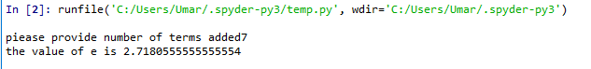

Figure no. 4.1(a): Output of task 1 with while loop

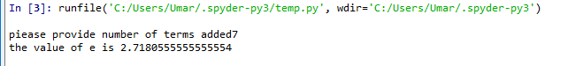 Figure no. 4.1(b): Output of task 1 with for loop

**Task 2:**

Ask the user to provide final exam marks of 10 students in ITC course in order to calculate the average. Use while loop for this purpose, and use break statement to exit the loop when an invalid input is given. Moreover, if marks greater than 100 are given, use continue statement to skip that number from average calculation.

**Code:**

count=0

x=10

while(x>0 and x<=10):

y=int(input("please enter the number of student obtained"))

if(y>100):

continue

if(y<0):

break

count=count+y

x=x-1

print(count/10)

**Output:**

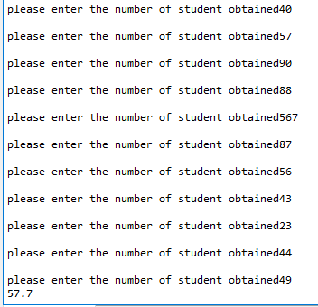

Figure no.4.2: Output of task 2

**Task 3:**

Store your first and last name in two variables. Use concatenation operator to concatenate your name and then print it. Also print the length of concatenated string using len0 function. Use for loop to separately print each character of concatenated string on output.

**Code:**

x="Umar"

y="Hayyat"

z=x+' '+y

print(z)

print(len(z))

for i in range(len(z)):

a=z[i]

print(a)

**Output:**

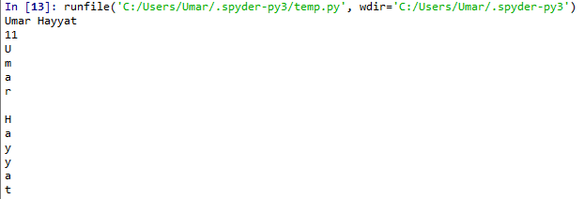

**Conclusion:**

In this lab, I learnt how prompt the user to enter number for the accuracy of value of ‘e’ by using for and while loop.

I also learnt how to calculate average of marks of student obtained by user using while loop.

I also learnt how to use concatenation operation.